The search functionality in Pega provides a convenient way to find rules work items and document s that you can upload etc…

Elastic search is a third party search engine which works effectively during high volume of rule usage

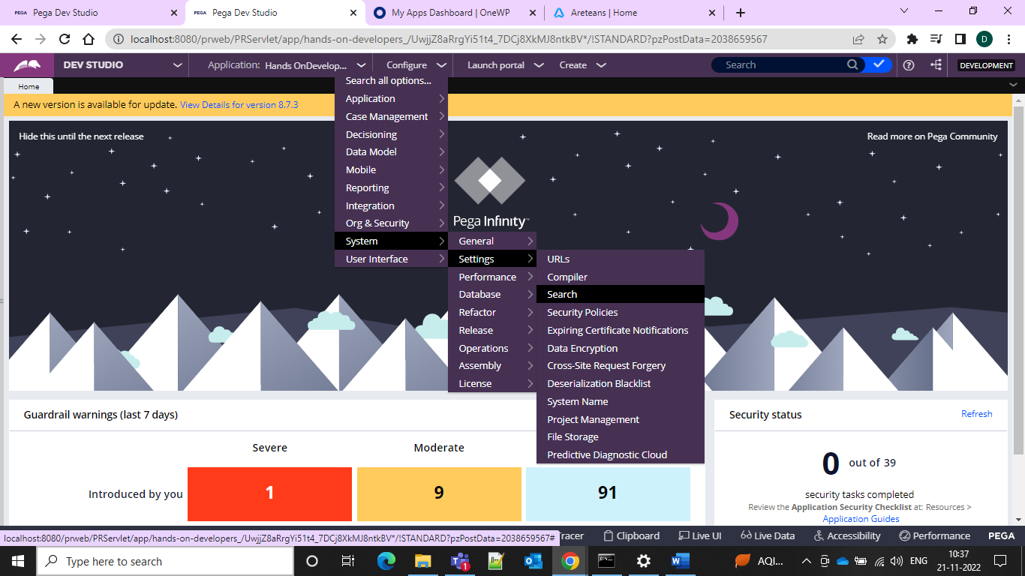

From the above we can find the search from configure system settings search

Search indexing is enabled here 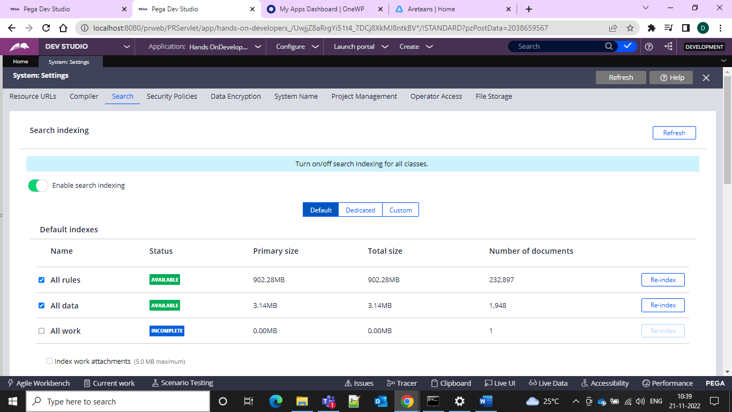

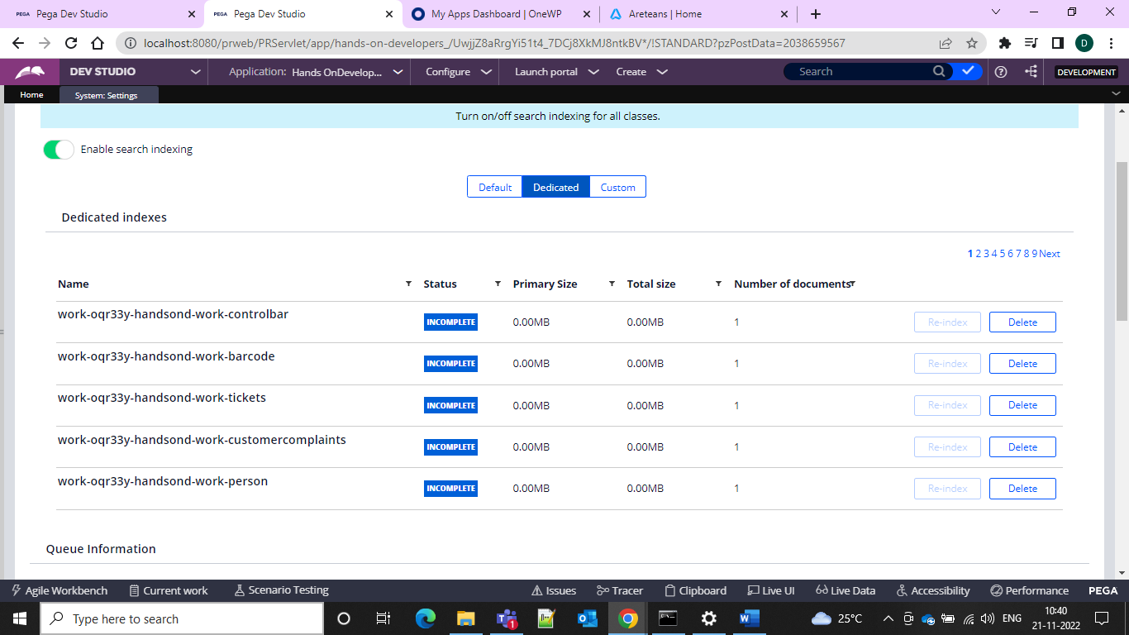

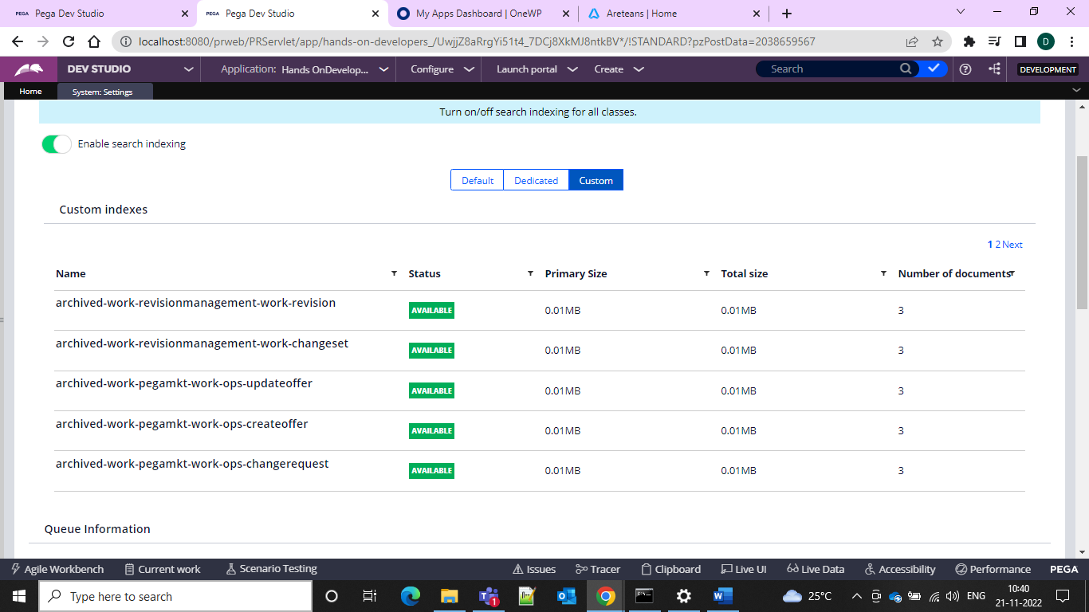

Before that we can have the rule search with all of them enabled

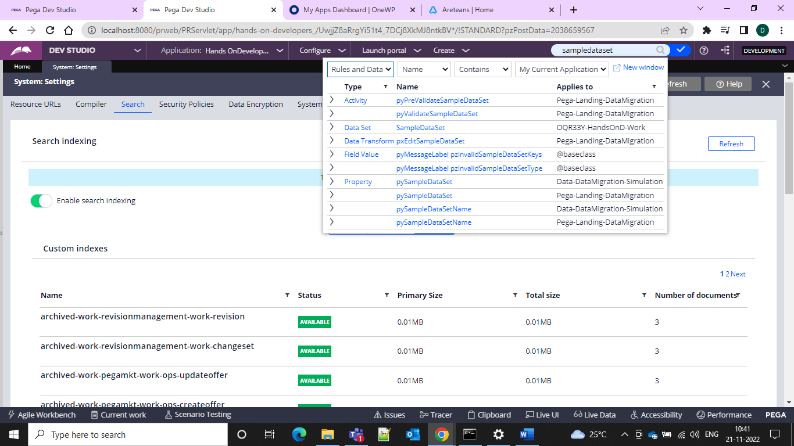

Now let us disable the search and see

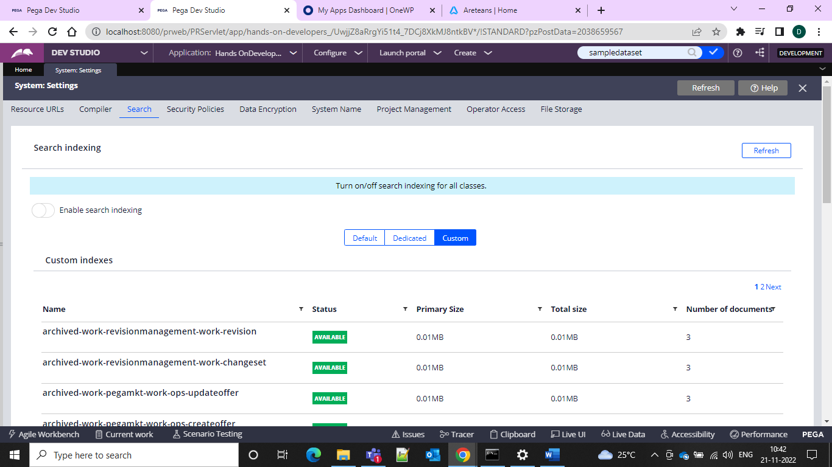

It is unable to get the rule

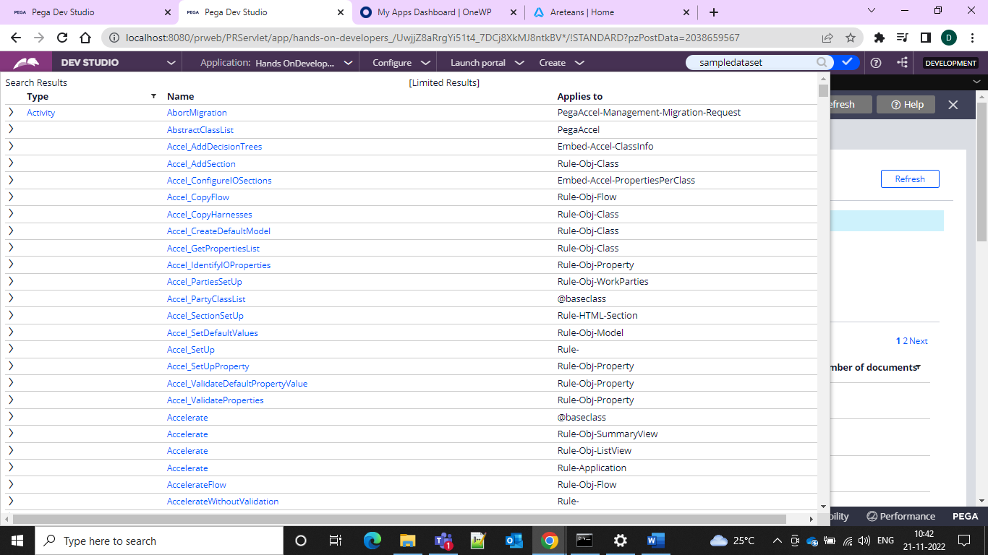

And popping out so all are seen

All Work means the case ID and the work object that we create

And if we want to do the indexing of the classes which are incomplete we can click on the Re-Index and do the changes

We can see our node status and change in the settings we can add it

We can fin the nodes in the PRPC fpolder under Temp files and we can add it

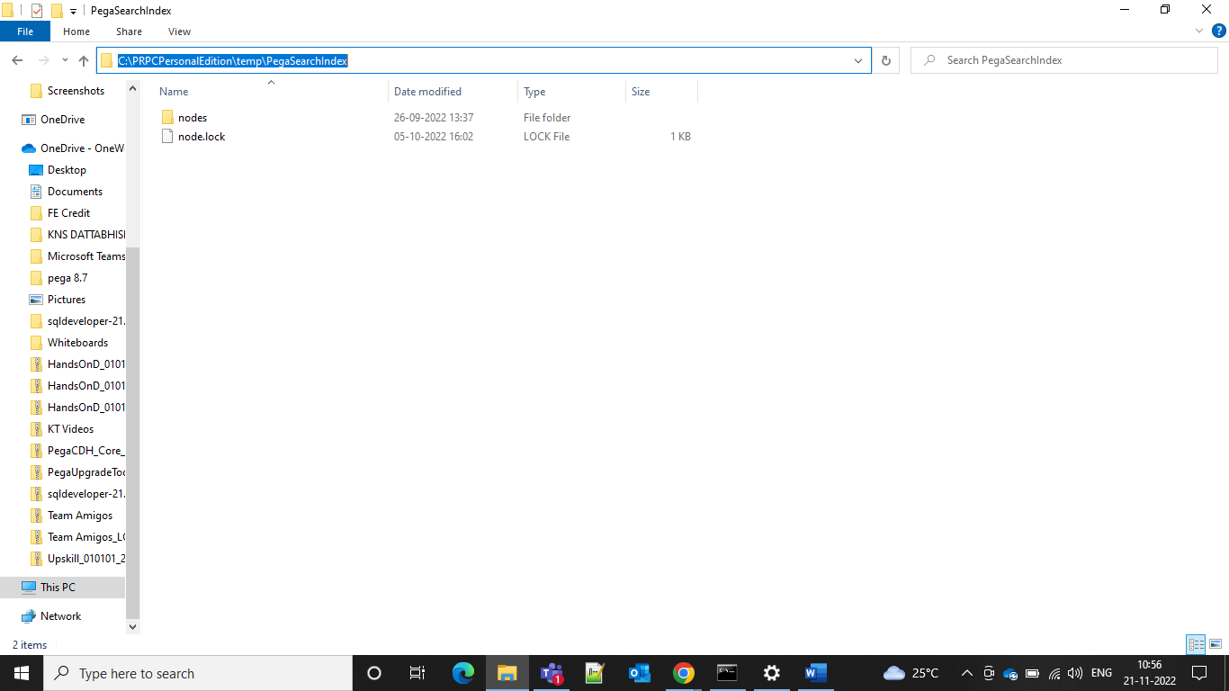

If we want to know the changes done elsewhere and we can do it by using the security setting

